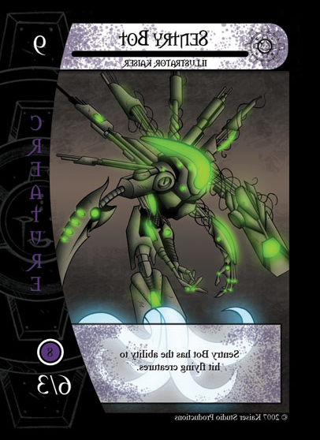

Expansion Logo

B

Can this Hero attack from the Bench

What is this Heros’ death bonus?

Does this char have “Absorb”?

Purchase price (Yellow orb?)

Retreat cost

Distance (Green orb)

Mana (Blue Orb)

[Gray if not used]

Translucent “potion symbol” in the center [for colorblind players]

Health (Red Orb)

Translucent “+” in the center [for colorblind players]

Attack 1 10

Attack details

Attack 2 60

Attack details

Character Art

POVERTY Logo

+10

A

Everything color coded

Copyright and signature

Class Logo

Class TItle

Card Name

$5

R5

D3

60

100

I.e

Classic or Tiers or Blockades or Quests  
or Monsters

This layout allows for your entire are to be displayed!

Notice the black border (this is used for printing purposes)

All stats are on the left of the card so that “fanned out” cards are easily read

Original: (it’s a Reversed image)  
